**FIN 334 – Fund Analysis: BlackRock Mid-Cap Growth Equity Inv A Fund**

**Question 1:**

|  |  |
| --- | --- |
| Portfolio Distribution | Percent |
| Large (10B to 50B) | 38.98 |
| Mid (2B to 10B) | 46.55 |
| Small (250MM to 2B) | 5.73 |
| Not Classified | 4.18 |

As this is a mid-cap fund the vast majority of stocks should be within the midcap portfolio distribution. This fund has done an alright job at this with 47% of the value of the portfolio within 2B-10B. However they also have a very large proportion of stocks that are within the large (10B-50B) market capitalizations that can be cause for some concern.

**Question 2:**

Portfolio Manager: Lawrence G. Kemp, who manages 12 total funds.

* BlackRock Midcap Growth Equity Portfolio (500M)
* Metropolitan Series - BlackRock Capital Appreciation Portfolio (1.7B)
* JNL/BlackRock Large Cap Select Growth Fund (1.6B)
* BlackRock Capital Appreciation Fund Inc. (3.2B)
* BlackRock Capital Appreciation V.I. Fund (345M)
* BlackRock Exchange Portfolio (174M)
* Pacific Select Fund - Large Cap Growth Portfolio (1.1B)
* BlackRock Master Focus Growth LLC (108M)
* PF Large Cap Growth Fund (152M)
* Allianz VIP Trust - AZL BlackRock Capital Appreciation Fund (484M)
* Laudus US Large Cap Growth Fund (2.1B)
* BlackRock Focus Growth Fund Inc. (107M)

TOTAL: 11.1B

This is cause for concern that he is the sole manager of 11 other funds. We are very concerned that he is not capable of managing all of these separate funds as effectively as if he could focus on a select few. We do not believe that he is able to give full attention to each fund. We believe that this fund, as it is relatively smaller than some of the other ones he manages and encompasses less than 5% of all assets that Mr. Kemp oversees, is primarily overseen by the two analysts, Kathryn Mak Mongelli and Philip H. Ruvinsky.

**Question 3:**

Basic Financial Ratios:

|  |  |  |  |  |
| --- | --- | --- | --- | --- |
| BMGAX |  |  | S&P 400 Index Fund |  |
| Avg P/E Ratio | 47.50 |  | Avg P/E Ratio | 30.11 |
| Avg P/B Ratio | 7.30 |  | Avg P/B Ratio | 3.94 |
| Avg Div Yld (%) | 0.35 |  | Avg Div Yld (%) | 1.66 |
| Avg Sales Growth (%) | 16.19 |  | Avg Sales Growth (%) | 4.23 |
| Price Momentum | 0.92 |  | Price Momentum | 1.04 |
| Relative Strength | 6.95 |  | Relative Strength | 10.95 |
| Beta | 0.84 |  | Beta | 0.88 |

As you can see above, BMGAX has a much higher P/E, P/B, and average sales growth than the comparable index of the S&P 400. This is to be expected as this is a growth fund.

**Question 4:**

|  |  |  |  |
| --- | --- | --- | --- |
|  | [Country Name](https://lionshares-m.factset.com/country_list.cfm?company_number=4000617&search=mutual&sort=country_name&order=asc) | [% of Port](https://lionshares-m.factset.com/country_list.cfm?company_number=4000617&search=mutual&sort=percent_number&order=asc) | [Mkt Val](https://lionshares-m.factset.com/country_list.cfm?company_number=4000617&search=mutual&sort=value&order=desc) |
| 1 | [United States](https://lionshares-m.factset.com/details.cfm?company_number=4000617&search=mutual&Country=United%20States) | 85.56 | 428,478,804 |
| 2 | [N/A](https://lionshares-m.factset.com/details.cfm?company_number=4000617&search=mutual&Country=N%2FA) | 4.18 | 20,942,739 |
| 3 | [Ireland](https://lionshares-m.factset.com/details.cfm?company_number=4000617&search=mutual&Country=Ireland) | 2.03 | 10,158,538 |
| 4 | [China](https://lionshares-m.factset.com/details.cfm?company_number=4000617&search=mutual&Country=China) | 1.44 | 7,216,024 |
| 5 | [Argentina](https://lionshares-m.factset.com/details.cfm?company_number=4000617&search=mutual&Country=Argentina) | 0.71 | 3,536,325 |
| 6 | [Norway](https://lionshares-m.factset.com/details.cfm?company_number=4000617&search=mutual&Country=Norway) | 0.67 | 3,349,063 |
| 7 | [United Kingdom](https://lionshares-m.factset.com/details.cfm?company_number=4000617&search=mutual&Country=United%20Kingdom) | 0.47 | 2,362,744 |
| 8 | [France](https://lionshares-m.factset.com/details.cfm?company_number=4000617&search=mutual&Country=France) | 0.38 | 1,903,953 |

This fund is primarily located within the United States with 86% of assets. It does have a small stake invested in Europe and Asia for approximately a total of 5%.

**Question 5:**

Morningstar rating: 3 stars

**Question 6:**

The best benchmark is the iShares S&P 400 Midcap Growth Fund

|  |  |
| --- | --- |
| Benchmark | Active Risk |
| Smallcap 600 | 6.63 |
| Russell 1000 | 6.16 |
| Russell 2000 | 6.50 |
| Midcap 400 | 5.99 |
| Largecap 500 | 6.49 |
| S&P 1500 | 5.92 |
| iShares S&P Midcap 400 Growth | 5.34 |

**Question 7:**

S&P 400 Midcap Growth

|  |  |  |  |  |  |
| --- | --- | --- | --- | --- | --- |
|  | YTD | 1 Year | 3 Year | 5 Year | 10 Year |
| IJK | 0.28% | -6.08% | 8.77 | 8.08 | 7.33% |

1 year: -6.08%  
3 year: 8.77%  
5 year: 7.33%

**Question 8:**

BGMAX

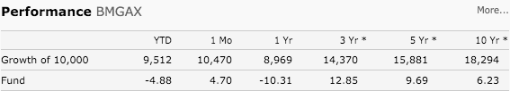  
1 year: -10.31%  
3 year: 12.85%  
5 year: 9.69%

**Question 9:**

The active risk with the benchmark is 5.34

**Question 10:**

An active risk of 5.34 would classify it as a growth fund in this class. This is exactly what the fund advertises themselves as, so the risks seem to be aligned with its goals.

**Question 11:**

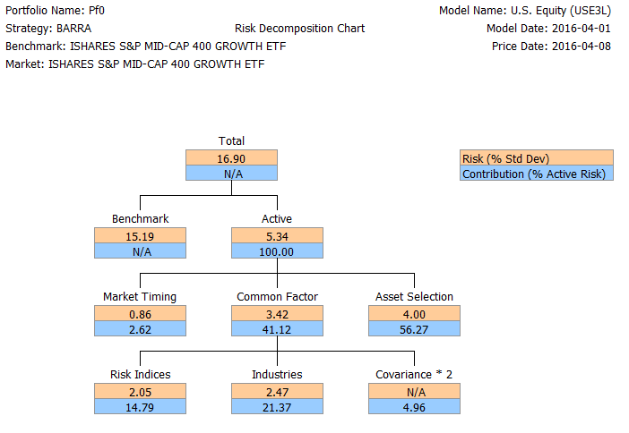

The common factor risk is 3.42%, which contributes 41.12% to the total active risk of the fund. Risk indices make a total contribution of 2.05% risk or 14.79% of the total active risk.

**Question 12:**

The fund is overweighted in Consumer Discretionary, Healthcare, and Information Technology. The fund in significantly under weighted in Financials and moderately underweighted in Utilities and Industrials. The under and over weightings make since there are not a lot of growth Financial, Utility and Industrial growth stocks but there are a lot of Healthcare and Information Technology. However, we believe that Consumer Discretionary is over weighted in relation to other high growth sectors (Healthcare and IT).

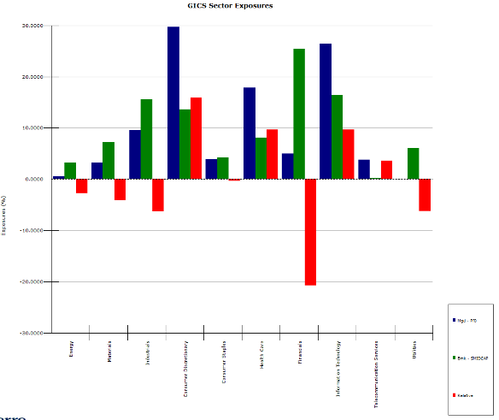

**Question 13:**

The fund is significantly overweighted in momentum, and growth which is to be expected given that this is a Growth fund. The fund is also over weighted in size which is a concern for us considering the fund claims to be a Midcap fund. The fund in under weighted in Value, Yield, and earnings yield which again is to be expected given that this is a growth fund. We also noticed that the fund is over exposed to highly levered firms, we would like to see this brought down.

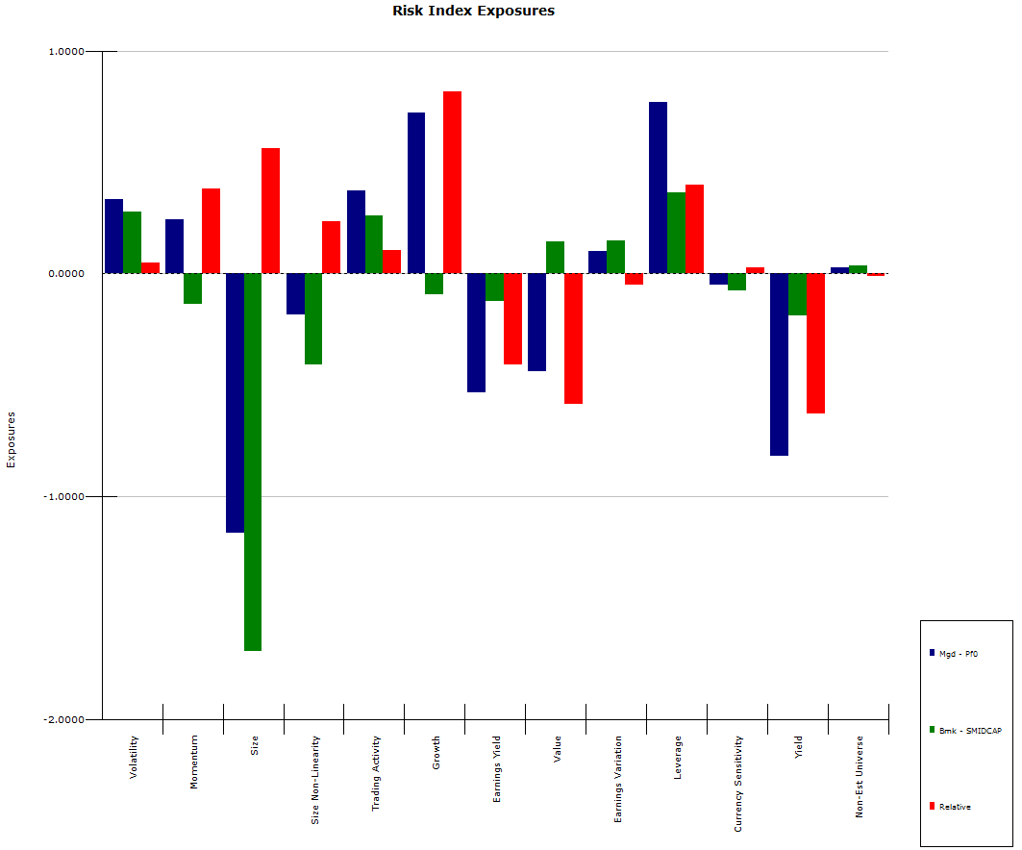

**Question 14:**

Stocks the provide the most risk:

1. Netflix (NFLX)
2. 58 Com Inc (WUBA)
3. Liberty Interactive Co (LVNTA)
4. Workday (WDAY)
5. Liberty Tripadvisor HL

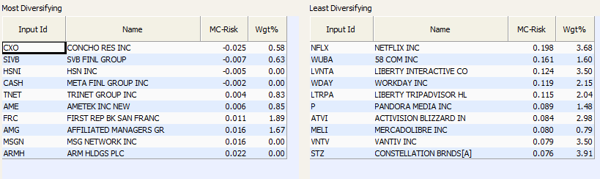

**Question 15:**

Stock that provide the most style risk:

1. 58 Com Inc (WUBA)
2. Netflix (NFLX)
3. Domino's Pizza Inc (DPZ)
4. Dexcom Inc (DXCM)
5. Constellation Brands (STZ)

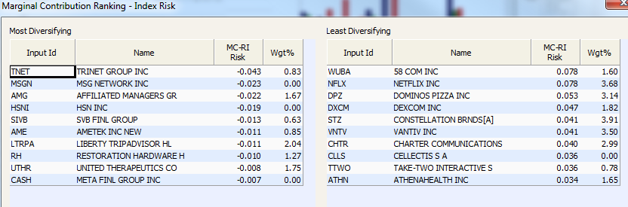

**Question 16:**

Stocks that provide the most Sector Risk

1. Mercadolibre Inc (MELI)
2. Netflix (NFLX)
3. Linkedin corp (LNKD)
4. Liberty interactive Co (LVNTA)
5. Workday Inc (WDAY)

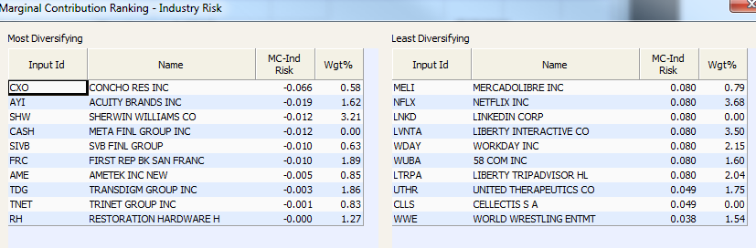

**Question 17: Sector Risk**

Sell LNKD (LinkedIn Corporation) & Buy HFWA (Heritage Financial Corporation)

To reduce sector risk we recommend the fund sell LNKD for the following reasons:

1. Fund was already overexposed to Information Technology sector
2. Stock scored very unattractive on the US Master Quant Screen with a score of 6.61
3. Had negative EPS with no EPS momentum.
4. Quant target price of 102.89% (-5.1% change)

We recommend the fund buy HFWA for the following reasons:

1. Fund already underexposed to Financial sector
2. Scores very well on US Master Quant Screen with score of 4.47
3. 82% Sales Growth
4. EPS momentum of 6.0.
5. Bloomberg DDM Target price of 25.98 (52.5% upside)
6. Quant target price of 22.18 (30.24% upside)

**Question 18: Style Risk**

Sell CHTR (Charter Communications) & Buy AOS (A.O Smith Corporation)

To reduce style risk we recommend the fund sell CHTR for the following reasons:

1. It scored very poorly on the US Master Quant Screen (lowest 1%)
2. No insider buying in last 6 months
3. 32% short interest as percentage of float
4. Bloomberg DDM Target price of 27.31 (86.5% downside)
5. Quant target price of 191.1 (5.6% downside)

We recommend the fund buy AOS for the following reasons:

1. Fund is underweight industrial stocks
2. Had higher revenue growth than industry average
3. Improved EPS by 25.4% in most recent quarter
4. Quant target price of 77.88 (1% upside)

**Question 19:**

Sell NFLX (Netflix) & Buy TX (Ternium SA)

We recommend the fund sell NFLX for the following reasons:

1. Had the most overall risk and 2nd most style and sector risk
2. Scored very poorly in US Master Quant Screen (bottom 1%)
3. No insider buying in past 6 months
4. Bloomberg DDM target price of 96.75 (6.8% downside)
5. Quant target price of 93.75 (9.7% downside)

We recommend the fund buy TX for the following reasons:

1. TX is one of the top 25 scoring stocks on the US Master
2. Long term growth rate of 36.9%
3. Bloomberg DDM target price of 198.13 (972.1% upside)
4. Quant target price of 26.78 (44.9% upside)

**Question 20:**

Yes, Netflix is in his top 13 holdings for 10 of the 12 funds he manages.

* BlackRock Midcap Growth Equity Portfolio #5
* Metropolitan Series - BlackRock Capital Appreciation Portfolio #12
* JNL/BlackRock Large Cap Select Growth Fund #11
* BlackRock Capital Appreciation Fund Inc. #10
* BlackRock Capital Appreciation V.I. Fund #10
* Pacific Select Fund - Large Cap Growth Portfolio #9
* BlackRock Master Focus Growth LLC #13
* PF Large Cap Growth Fund #9
* Allianz VIP Trust - AZL BlackRock Capital Appreciation Fund #11
* Laudus US Large Cap Growth Fund #11

**Question 21:**

The information ratio of the fund is -.62 which leads us question the future performance of the fund.

**Question 22:**

We would not recommend a salary increase or decrease for Lawrence Kemp for the following reasons:

1. The fund has overperformed the market over the last 5 years by 1.61% annualized
2. Underperformed by 4.23% over the last year which is concerning.
3. Information ratio of -0.62 which causing worry about the future performance of the fund